**Wavelet and spectral analysis of heart sound for automated diagnosis of cardiac disorders**

A thesis submitted in partial fulfillment for the requirements of the

degree of

Bachelor of Science in

Electrical and Electronic Engineering

Department of Electrical & Electronic Engineering

February 2021

**ABSTRACT**

Body auscultation is one of the main common clinical diagnostic technique for assessment of cardiac disorders. This clinical method is cheap and effective and requires professional doctors to understand and interpret the heart sound for diagnosis of cardiac diseases. This thesis presents basic analysis and comparison of heart sounds recorded from healthy and unhealthy subjects for automated screening of cardiac disorders. Some characteristics of heart sounds such as probability distribution of amplitude and frequency contents are quantified using signal processing to automate the diagnosis of cardiac disorders. Experiments were carried on the Heart sounds database created under National Institute of Health (National Center for Research Resources) and results are encouraging. The experiment results indicates enough discrimination between heart sounds from healthy and unhealthy heart required for automated screening of cardiac disorders using signal processing and Wavelet Analysis.

**CONTENTS**

Chapter 1 1

1 Introduction 1

1.1 Heart Disease Categories 1

1.1.1 Electrical Disorders 2

1.1.2 Circulatory Disorders 5

1.1.3 Structural Disorders 6

1.2 Heart Disease Symptoms 6

1.2.1 Symptoms of heart disease in your blood vessels (atherosclerotic disease) 6

1.2.2 Heart disease symptoms caused by abnormal heartbeats (heart arrhythmias) 7

1.2.3 Heart disease symptoms caused by heart defects 7

1.2.4 Heart disease symptoms caused by weak heart muscle (dilated cardiomyopathy) 8

1.2.5 Heart disease symptoms caused by heart infections 8

1.2.6 Heart disease symptoms caused by valvular heart disease 9

1.3 Separating Heart Sounds from Lung Sounds 9

1.4 PLX-DAQ Tool 10

1.5 Arduino Uno 11

1.6 Matlab R2020a 11

1.7 Objectives 12

1.8 Original Contribution 12

2 Literature Review 13

2.1 Literature Review 13

3 Research Methodology 17

3.1 Data Acquisition 17

3.2 Signal and Spectral analysis 18

3.2.1 Signal 18

3.2.2 Spectrogram 18

3.2.3 Histogram 19

3.2.4 Normal Distribution 19

3.2.5 Mean value comparison: 19

3.3 Wavelet Transform 20

3.3.1 Wavelet 20

3.3.2 DWT 20

3.3.3 Wavelet Families 21

3.3.4 Wavelet Thresholding 23

3.3.5 Wavelet Filters 24

3.3.6 Filter Banks 25

3.3.7 Wavelet Coefficient 25

3.3.8 Wavelet Energy 25

4 Result & Discussion 26

5 Conclusion and Future Work 40

5.1 Conclusion 40

5.2 Future Work 40

**LIST OF FIGURES**

Figure 1.1. Arrhythmia [23]. 1

Figure 1.2. Different kinds of heart disease. 5

Figure 1.3. Heart and lung visual. 10

Figure 1.4: Arduino Uno [19]. 11

Figure 3.1. Condenser microphone and its Circuit diagram. 17

Figure 3.2. Daubechies wavelet [21]. 22

Figure 3.3. Symlets wavelet [22]. 22

Figure 4.1. Amplitude distribution of heart sound recorded from healthy subjects. 26

Figure 4.2. Amplitude distribution of heart sound recorded from unhealthy subjects. 26

Figure 4.3. Comparison between healthy and unhealthy heart sound signal. 27

Figure 4.4. Spectrogram of heart sound recorded from healthy subjects. 28

Figure 4.5. Spectrogram of heart sounds recorded from unhealthy subject. 28

Figure 4.6. Plot of probability distribution of heart sound recorded from healthy subject. 29

Figure 4.7. Plot of probability distribution of heart sound recorded from unhealthy subject. 29

Figure 4.8. Plot of probability distribution of heart sound recorded from healthy subject. 30

Figure 4.9. Plot of probability distribution of heart sound recorded from unhealthy subject. 30

Figure 4.10. Mean value of healthy and unhealthy subject. 31

Figure 4.11. De-noised detailed coefficient using sym4 level4 of healthy subject. 32

Figure 4.12. De-noised detailed coefficient using sym4 level4 of unhealthy subject. 32

Figure 4.13. Detailed Coefficient before de-noising the signal of healthy subject. 33

Figure 4.14. Detailed Coefficient before de-noising the signal of unhealthy subject. 33

Figure 4.15. Detailed coefficient after de-noising the signal of healthy subject. 34

Figure 4.16. Detailed coefficient after de-noising the signal of unhealthy subject. 34

Figure 4.17. De-noised approximation coefficient using sym4 level4 of healthy subject. 35

Figure 4.18. De-noised approximation coefficient using sym4 level4 of unhealthy subject. 35

Figure 4.19. Approximation Coefficient before de-noising the signal of healthy subject. 36

Figure 4.20. Approximation Coefficient before de-noising the signal of unhealthy subject. 36

Figure 4.21. Approximation Coefficient after de-noising the signal of healthy subject. 37

Figure 4.22. Approximation Coefficient after de-noising the signal of unhealthy subject. 37

Figure 4.23. Energy of DWT co-efficient of healthy and unhealthy subjects. 38

Figure 4.24. Zoomed version of energy of DWT co-efficient of unhealthy subjects 38

**LIST OF TABLES**

Table 3.1: Range of Threshold to Separate Healthy and Unhealthy Heart Sounds for Automated Diagnosis of Cardiac Disorders. 39

# Chapter 1

# Introduction

Millions of people experience irregular or abnormal heartbeat, called arrhythmias, at some point in their lives. Most of the time, they are harmless and occur in healthy people free from heart disease. However, some abnormal heart rhythms may be serious or even fatal. Other types of heart disease may also increase the risk of arrhythmias.

## Heart Disease Categories

Electrical: abnormal heart rhythms (arrhythmias) are caused by problems with the electrical system that regulate a steady heartbeat. The heart rate may be too slow or too rapid; it may remain steady or become erratic (irregular and disorganized) . Some arrhythmias are very serious and cause sudden cardiac death, while others can be problematic but not life-threatening. Fig 1.1 shows both normal and abnormal heart sound named tachycardia. They have differences in signal.

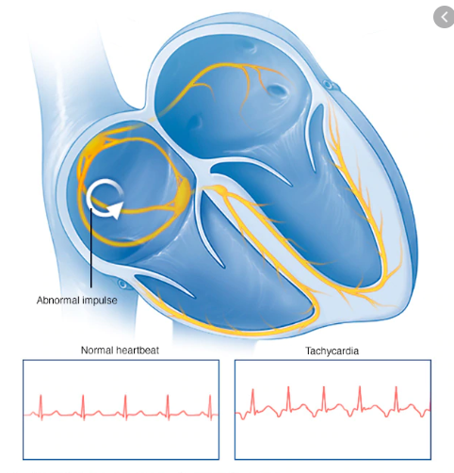

Figure 1.1. Arrhythmia [23].

Circulatory: high blood pressure and coronary artery disease (causing blockages in the pipes (arteries) that supply blood to the heart) are the primary causes of disorders in the blood vessels . They can result in a stroke or heart attack, which can be devastating. Fortunately, there are many prevention and recovery services accessible.

Structural: heart muscle disease (cardiomyopathy) and congenital defects (problems with the formation of the heart and blood vessels that are present from birth) are two problems that can affect the heart muscle or the valves.

### Electrical Disorders

Arrhythmias that start in the heart's upper chambers, the atria, include:

#### [Atrial Fibrillation (AF or AFib)](https://www.hrsonline.org/atrial-fibrillation-afib)

In AFib, the heartbeat is irregular and fast due to disorganized signals from the electrical system of the heart. The upper chambers of the heart may be beaten as often as 300-400 times a minute, approximately four times faster than normal. Although AFib is not life-threatening, it can lead to other rhythm problems, feeling tired all the time, and heart failure (with symptoms such as filling up with fluid, swelling of the hands, legs and feet, and shortness of breath) [20]. People with AFib are five times more likely to have a stroke than people with no condition. Physicians often prescribe blood thinners (anticoagulants) to patients with AFib to reduce this higher risk of stroke.

#### [Atrial Flutter (AFL)](https://www.hrsonline.org/atrial-flutter)

Atrial flutter is similar to AFib since it also produces a fast beat in the atria. However, AFL is triggered by a single electrical wave that circulates very quickly in the atrium, about 300 times a minute. This leads to a very fast, but slow, heartbeat. It can also raise the likelihood of a stroke.

#### [Sick Sinus Syndrome (SSS)](https://www.hrsonline.org/sick-sinus-syndrome)

Sick sinus syndrome is not a condition, but a set of signs or symptoms that indicate that the normal electrical pacemaker of the heart, the sinus node, is not functioning correctly. In SSS, the heart rate can alternate between slow (bradycardia) and rapid (tachycardia), often in conjunction with atrial fibrillation atrial flutter. SSS therapy typically includes the implantation of a pacemaker, often along with drugs.

#### Sinus Tachycardia

Inoffensive faster rhythm, sinus tachycardia is a natural rise in heart rate that occurs with fever, excitement, and exercise. Treatment is not needed except in cases where it is caused by an underlying condition, such as anemia (low blood count) or hyperthyroidism (overactive thyroid gland), or occasionally occurs regularly and without a specific cause (inappropriate sinus Tachycardia).

Arrhythmias that occur in the heart's lower chambers, the ventricles, include:

#### Ventricular Tachycardia (VT):

Life-threatening arrhythmia, ventricular tachycardia, is usually seen along with a severe heart failure, but also occurs in individuals with normal hearts. Since VT can lead to ventricular fibrillation (a dangerously rapid and disorganized heartbeat), it is a severe condition that requires aggressive treatment and follow-up. Treatment options include surgery, radiofrequency ablation (scarring or burning the region of the heart tissue that induces irregular rhythm) and/or medicine. People with VT are also shielded by a defibrillator (a system that can stimulate the heart from a painful heartbeat) that is implanted in the body.

#### Ventricular Fibrillation (VF)

#### Sudden cardiac arrest (SCA) caused by ventricular fibrillation is the cause of half of all cardiac deaths. In VF, the heartbeat is fast and chaotic, causing the lower chambers of the heart or ventricles to spasm. Sometimes a heart attack (blocking of the heart pipes/arteries) can lead to VF. VF is sudden, occurs without warning, and stops the heart from working. The lack of oxygen in the body, especially in the brain, is deadly. SCA is caused by an electrical problem and although it can be triggered by a heart attack (myocardial infarction), a circulatory (plumbing) problem caused by clogged blood vessels that cut off the blood supply to the heart, it is not the same as a heart attack. Although CPR may help, the only truly effective treatment for VF is defibrillation, which uses paddles or electrodes to "shock" the heart back to normal rhythm. Without treatment, a person with VF will suddenly pass away and die.

Other terms to know include:

#### Premature Contractions

Extra, early, or "skipped" beats are the most frequent source of erratic heart rhythm. They may begin in the upper or lower chambers of the heart (atrial or ventricular premature contractions).

#### Long QT Syndrome (LQTS)

Long QT Syndrome is an electrical system disorder. It may be inherited, caused by taking certain medications, or caused by a combination of both. People with LQTS are at risk for VF, the most dangerous cardiac rhythm that causes sudden death.

#### [Heart Block](https://www.hrsonline.org/heart-block)

When electrical signals from the upper chambers of the heart (atria) cannot travel to the lower chambers (ventricles), a heart block occurs. The lower chambers of the heart (ventricles) then beat too slowly, lowering the amount of oxygen to the body and brain. This causes a slow pulse and can lead to a lack of energy, a lack of direction or a fainting.

#### Syncope (Fainting)

#### Fainting, or feeling as if one might pass out, can be caused by serious heart rhythm disorders and needs to be evaluated carefully. Sometimes the cause is not heart related, as in cases of low blood sugar, but it can still be dangerous due to the risk of injuries from falling.

### Circulatory Disorders

#### **Heart Attack (Myocardial Infarction)**

#### When arteries become so clogged that the flow of blood to the heart is reduced or stopped, the lack of oxygen can damage or kill the heart muscle, causing a heart attack. Knowing the symptoms of a heart attack and getting immediate emergency treatment can limit or prevent heart muscle damage.

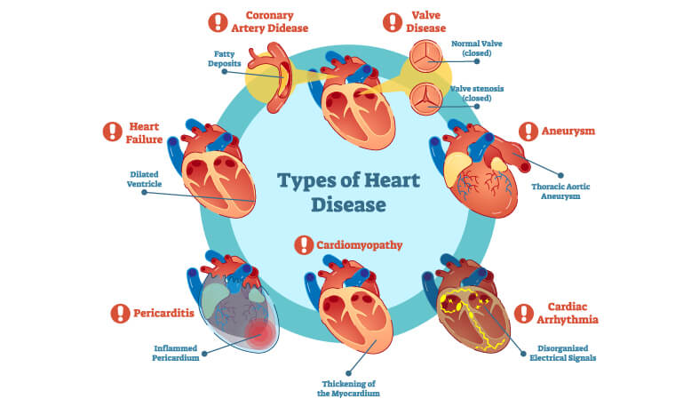

Figure 1.2. Different kinds of heart disease.

#### **Stroke**

Strokes (brain attacks), while not true heart problems, are caused by blockage or reduced blood flow to the brain. While certain strokes occur when a blood vessel bursts, most of them are due to clogged or blocked vessels in the brain, the same way that clogged vessels in the heart can cause a heart attack. Abnormal heart rhythms, such as atrial fibrillation and atrial flutter, can lead to blood clots in the heart. Such blood clots can break down and migrate to the brain, block the artery, and cause a stroke. Both strokes face serious health threats.

### Structural Disorders

#### **[Heart Failure](https://www.hrsonline.org/heart-failure)**

Cardiac failure, or cardiomyopathy, happens when the heart muscle is too unable to pump blood through the body effectively. Deterioration of heart disease can stop or slow early diagnosis and treatment.

#### **Heart Valve Problems**

Heart valve disorders may be acquired or developed on their own, affecting the capacity of the heart to pump blood safely from the chamber to the chamber and to the rest of the body. Treatment options include medicine, surgery, and the insertion of new valves using catheters (thin tubes inserted in the arteries and heart).

## Heart Disease Symptoms

Heart disease symptoms depend on what type of heart disease you have.

### Symptoms of heart disease in your blood vessels (atherosclerotic disease)

The signs of cardiovascular disease will be different for both men and women. For instance, men are more likely to experience chest pain; women are more likely to experience other symptoms along with chest pressure, such as shortness of breath, nausea and extreme fatigue.

Symptoms can include the following:

• Chest pain, tightness of the chest, chest pressure and chest discomfort; (angina)

• Breathing with shortness

• Discomfort, numbness, fatigue or coldness in your legs or arms as the blood channels are narrowed in certain areas of the body.

• Pain in the spine, chin, throat, upper belly, or in the back;

Cardiovascular disorder will not be diagnosed until you have a heart attack, angina, stroke, or heart failure. It is important to take care of cardiovascular symptoms and discuss your issues with your doctor. Cardiovascular disorder may also be diagnosed early on by routine tests.

### Heart disease symptoms caused by abnormal heartbeats (heart arrhythmias)

Cardiac arrhythmia is an abnormal heartbeat. Your heart may be beaten too quickly, too slowly or irregularly. Symptoms of heart arrhythmia may include:

• Fluttering in the chest

• Cardiac racing beat (tachycardia)

• Slow heartbeat; (bradycardia)

• Chest pain or discomfort

• Breathing shortness

• Light heading

• Dizziness

• Fainting (syncope) or near fainting

### Heart disease symptoms caused by heart defects

Serious congenital heart defects—defects that you are born with—are usually evident shortly after birth. Symptoms of heart defect in children could include:

• Color of pale gray or blue skin (cyanosis)

• Swelling of the legs, abdomen or areas around the eyes

• In infants, shortness of breath during feeding, leading to poor weight gain

Less serious congenital heart defects are often not diagnosed until later in childhood or in adulthood. Signs and symptoms of congenital heart defects that are not usually immediately life-threatening include:

• Easily shortening breath during exercise or activity;

• Easily tiring during exercise or activity;

• Swelling in the hands, ankles or legs

### Heart disease symptoms caused by weak heart muscle (dilated cardiomyopathy)

In early stages of cardiomyopathy, you may have no symptoms. As the condition worsens, symptoms may include:

* Breathlessness with exertion or at rest
* Swelling of the legs, ankles and feet
* Fatigue
* Irregular heartbeats that feel rapid, pounding or fluttering
* Dizziness, lightheadedness and fainting

### Heart disease symptoms caused by heart infections

Endocarditis is an inflammation that damages the inner membrane, which divides the chambers and valves of the heart (endocardium). Symptoms of heart infection can include:

• Fever

• Breathing shortness

• Exhaustion or tiredness

• The swelling of the thighs or belly

• Shift in the rhythm of the heart

• Dry or constant coughing

• Skin rash with irregular patches

### Heart disease symptoms caused by valvular heart disease

The heart has four valves—aortic, mitral, pulmonary and tricuspid valves—that are open and close to the direct flow of blood into the heart. Valves can be compromised due to a number of conditions leading to narrowing (stenosis), leakage (regurgitation or insufficiency) or insufficient closure (prolapse).

Depending on which valve does not function properly, the signs of valve heart failure usually include:

• Fatiga

• Breathing shortness

• Irregular heart beat;

• Swollen knees or feet

• Pain in the abdomen

• Fainting; (syncope)

## Separating Heart Sounds from Lung Sounds

Auscultation is a surgical technique that gives a general idea of the actions of the heart and lung as the practitioner listens to the rhythm of the air. Owing to the fact that the sounds of these organs differ in time and frequency realms, essential affections in one of them may be dismissed. The purpose of this work, for example, is to incorporate two separate methods of cardiac and pulmonary sound isolation. Second, we add modulation filters to the time-frequency representation of the initial signal reported in the chest. Second, we apply an iterative wavelet decomposition and reconstruction filter algorithm. Results demonstrate that all signals are correctly segregated. Taking lung signals as noise, we determine that signal to noise (SNR) ratio is 10.21 for the first method and for 6.61 the second [21].

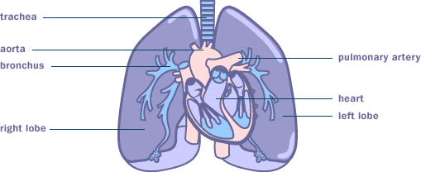

Figure 1.3. Heart and lung visual**.**

## PLX-DAQ Tool

PLX-DAQ is an add-on data acquisition tool for Microsoft Excel for the Parallax microcontroller. All of our microcontrollers attached to any PC sensor and serial port will now transmit data directly to Excel. PLX-DAQ has the following features: plot or graph data as it arrives in real time using Microsoft Excel. PLX-DAQ has the following characteristics:

* Plot or graph data as it arrives in real-time using Microsoft Excel
* Record up to 26 columns of data
* Mark data with real-time (hh:mm:ss) or seconds since reset
* Read/Write any cell on a worksheet
* Read/Set any of 4 checkboxes on control the interface
* Example code for the BS2, SX (SX/B) and Propeller available
* Baud rates up to 128K
* Supports Com1-15

## Arduino Uno

The Arduino Uno of fig 1.2 is an open-source microcontroller board based on a microchip ATmega328P microcontroller developed by Arduino. The board is equipped with a set of input/output (I/O) digital and analog pins that can be connected to different expansion boards (shields) and other circuits. The board has 14 digital I/O pins (six capable of PWM output), 6 analog I/O pins, and is programmable with the Arduino IDE (Integrated Development Environment) via the USB type B between 7 and 20 volts.

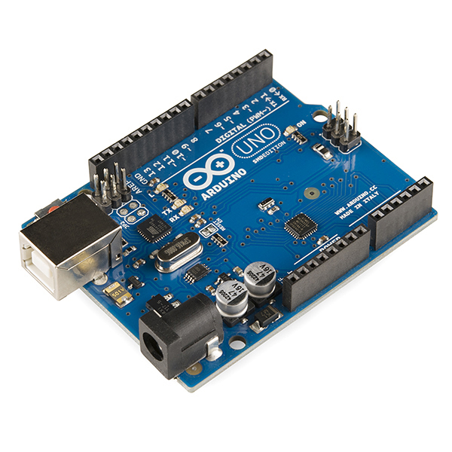

Figure 1.4: Arduino Uno [19]**.**

## Matlab R2020a

MATLAB is the high-performance technical computing language. It integrates computing, visualization and programming in an easy-to-use environment where issues and solutions are expressed in familiar mathematical notation. Typical uses include: data analysis, exploration and visualization, deep learning and machine learning, signal processing and communication, image and video processing, control systems, test and measurement, computational finance, and computational biology.

## Objectives

1. Collect heart sound data from the person lives far from medical facility zone
2. Spectral analysis of heart sound
3. Wavelet analysis of heart sound
4. Find out whether a person healthy or unhealthy by his heart sound

## Original Contribution

Real data is used for my thesis analysis. I have found the real data through stethoscope with some electronic devices. Body auscultation is one of the most important clinical testing methods for the examination of cardiac disorders. This medicinal approach is inexpensive and efficient and allows trained physicians to recognize and analyze the sound of the heart for diagnosis. But in rural area of Bangladesh, there is scarcity of medical expert who can give us proper interpretation of my heart sound. To outgrow this obstacle I converted stethoscope heart sound into electrical signal via Condenser microphone and then PLX-DAQ tools. PLX-DAQ converted serial monitor data of Arduino into Excel data file. Matlab can read those excel files and interpret the sound to signal. Signal was then De-noised and ready for further analysis to extract some features of the signal so that we can compare the normal heart sound with abnormal heart sound and come to a decision whether a person is healthy or unhealthy by simply collecting his heart sound.

**Chapter 2**

# Literature Review

## Literature Review

Martin Gjoreski et al, 2020 developed a system with combination of machine learning (ML) and deep learning (DL) to expert chronic heart failure (CHF) using PCG audio recording of patients. It further determined various CHF phases and can compare them to see the heart condition of patient in different phases with 93.2% accuracy. Time and spectral representation of signal is being used here. A homemade automated CHF detection device can be made in future using this technique of continuous observation of heart [1].

PAN Qiao et al, 2020 introduces a method for classifying adolescent heart sound data based on wavelet analysis and random forest classifier. Heart sound segmentation algorithm is used to segment the positions of S1, systole, S2, and diastole, S3.They showed that random forests can obtain the best classification result. Result was improved by 3.01% than normal time and frequency analysis of heart sound. Elderly person’s heart sound data can be used for further research using symlet instead of bi-orthogonal wavelet [2].

Kun-Hsi Tsai et al, 2020 proposed a novel periodicity-coded deep auto-encoder (PC-DAE) approach to separate mixed heart-lung sounds in an unsupervised manner via the assumption of different periodicities between heart rate and respiration rate. This method used periodic analysis algorithm to improve the separation of sounds with overlapped frequency bandwidth. Future extension of PC-DAE to the conditions where additional physiological data is available, such as ECG, photoplethysmogram, and blood pressure signals [3].

Haixia Li et al, 2020 proposed a system to distinguish between diastolic murmurs between in Coronary Heart disease (CHD) and in valvular disease. Then using empirical wavelet transform diastolic heart sound was divided in three modes and result was satisfactory Se is 94.7%, Pp is 93.4% and Oa is 88.7%. For further accumulation of heart sound data, intelligent algorithms such as support vector machine can be used to P3 and result may be improved [4].

Sangita Das et al, 2020 presented an unsupervised approach to detect the positions of S1, S2 heart sound events in a Phonocardiogram (PCG) recording. Gammatone filter bank features are used to characterize the spectral pattern and an unsupervised spectral clustering technique is employed for segmentation of S1/S2 and non-S1/S2 heart sound events. This method offers a maximum F1-score of 98% and 92.5% for normal and abnormal PCG data [5].

Haixia Li et al, 2019 applied Empirical Wavelet Transform (EWT) to decompose S1 and extracted the instantaneous frequency (IF) of mitral component (M1) and tricuspid component (T1) by using Hilbert Transform. Fltering, resampling, normalization and segmentation is done then S1 is decomposed into several modes based on EWT, at last k-mean cluster algorithm is applied to cluster the IF of different modes. Result was astonishing as S1 with abnormal amplitude change, SeD94.4%, PpD95.7% and OaD90.6% [6].

Upreete Pratima et al, 2019 presented a simple time-varying spectral feature for heart sound classification. It presents a simple time-varying spectral feature called centroid frequency for heart sound classification. Proposed feature can be used with any classifier for both two-class and multi-class classification problems and yields excellent results [7].

Xiao et al, 2019 developed a deep learning-based computer-aided system for pediatric congenital heart diseases (CHDs) diagnosis using two novel light-weight convolution neural networks (CNNs). Heart sounds from newborns and children with physicians’ annotations was used to construct a pediatric heart sound dataset. Results demonstrate the superiority of the proposed methods in terms of diagnosis performance and parameter consumption in the application of internet of things. Higher diagnosis accuracy might be further investigated [8].

Elamaran et al, 2018 analyzed four PCG signals spectrally with fault and the recovered ones along with the execution time results in each using Matlab R2016b tool. This paper dealt with how to recover the spectrum from the faulty one with the heart sound case reports. As FFT is very important in medical science for extracting any kinds of feature for further analysis spectral fault recovery does the job [9].

Amit Krishna Dwivedi et al, 2018 provided an in-depth systematic review and critical analysis of all existing approaches for automatic identification and classification of heart sounds. There is still work to be done to develop robust methods for identification and classification of various events in the cardiac cycle, so that this could be effectively used to improve the diagnosis and management of cardiovascular diseases in combination with wearable mobile technologies [10].

Demir et al, 2018 studied, the heart which is one of the most important organ affecting life sustaining function is examined whether it works properly in a certain rhythm or not. An effective algorithm both analyzing and categorizing Phonocardiogram signals (PCG) which is significant at diagnosis of diseases is presented. Extraction maps of Convolutional Neural Networks (CNN) are used to educate the data of images and it was categorized with Support Vector Machine (SVM) [11].

Ashok Mondal et al, 2018 proposed a novel heart sound de-noising technique has been introduced based on a combined framework of wavelet packet transform (WPT) and singular value decomposition (SVD). Most informative node of wavelet tree is selected then the coefficient corresponding to the selected node is processed by SVD technique and biological information preserved in de-noised heart sound (HS) signal is evaluated by k-means clustering algorithm. Result was satisfactory [12].

Anna Glazova et al, 2018 developed a system for remote monitoring the asthma patient based on the assessment of the duration of tracheal sound. One of the fact that they couldn’t make a fully autonomous system and it can be further exposed. An IOT based system could be introduced here for remote area’s patient data observation [13].

Zhi Li et al, 2018 proposed an approach by applying machine learning algorithm to heart rate variability features extracted from ECG signal. It would be interesting to extend the models to predict SVT events based on ECG recordings several minutes before onset [14].

Mohan Mishra et al, 2017 analyzed heart sounds in wavelet domain for automatic screening of cardiac disorders. They extracted Detailed and Approximation coefficient of DWT then analyzed it for discrimination between normal and abnormal heart sound. Energy level of DWT is also calculated for comparison purpose. Other transform domain rather than db4 can also be used to find out the outcome [15].

Mohammad-Taheriet al, 2016 analyzed a method for VT & VF detection using slope of ECG signal. Normal Sinus Rhythm(NSR), VT & VF for assessing the slope analysis method’s efficiency. Here 70% of dataset was selected for training and the rest was used for the test [16].

Several techniques are being used by authors to find out the features of heart sound. Some of the techniques are machine learning (ML), deep learning (DL), wavelet analysis and random forest classifier, deep learning-based computer-aided system, slope analysis method etc. Differentiation between heart and lung sound was also made. There are some limitation in almost all papers. Many researchers made a comparison between healthy and unhealthy sound. Some criteria or condition was imposed upon the heart sound. Differentiate healthy people from unhealthy one is done based on these conditions.

**Chapter** **3**

# Research Methodology

## Data Acquisition

PhysioNet is a site for all kinds medical database [22]. It provides reliable and quality data for research in various sections of the biomedical. Researcher all over the world uses their data i.e ECG, EEG for extracting different feature using data.

But we all know that primary data is always preferable as it gives us direct connection with source data. Rather physical data of a subject is essential to analysis his/her health condition. That’s why we came out with an idea for collecting heart sound using medical stethoscope which is used by specialist for body auscultation. We used stethoscope with microphone condenser and few arrangement with Arduino Uno and it will give us serial monitor data in Arduino software. PLX-DAQ software is used for converting this serial monitor data into excel file. Then those excel file can be read by Matlab and after de-noising the signal we found our original heart data signal.

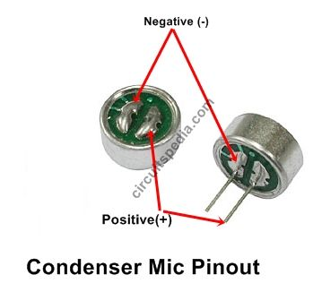

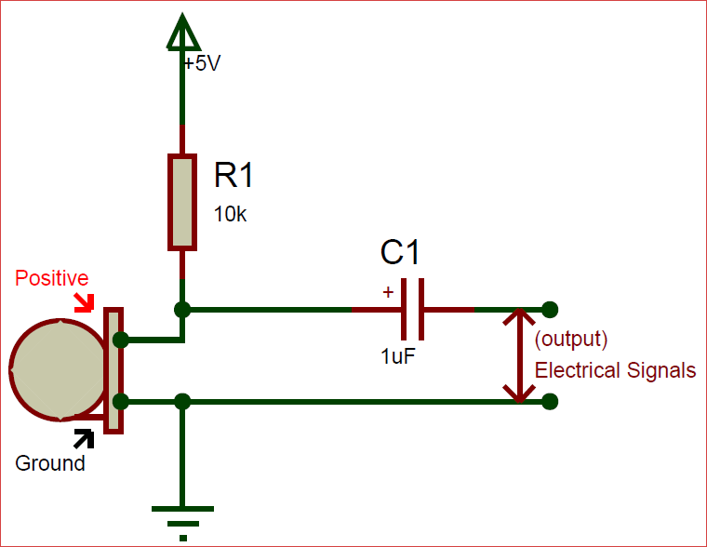

Figure 3.1. Condenser microphone and its Circuit diagram.

Fig. 4.1 shows a condenser type microphone which can multiply the signal. It receives small heart sound via stethoscope and convert it into electrical signal. Some electronic devices such as capacitor, resistors are being used for this purpose. It has two pin out positive and negative and should be connected accordingly otherwise it won’t work even be destroyed.

## Signal and Spectral analysis

### Signal

The message encoded by changing the electrical current voltage is considered an electronic signal. Electromechanical transducer, any form of instrument that converts an electrical signal into a sound wave (as in a loudspeaker) or converts a sound wave into an electrical signal (as in the microphone). Microphones are a kind of transducer-a system that transfers energy from one medium to another. Microphones transform acoustic energy (sound waves) into electrical energy (the audio signal). Electrical noise is the result of more or less spontaneous electrical signals being connected to circuits where they are unwanted, i.e. where information-carrying signals are interrupted. Noise happens on both power and signal circuits, but generally speaking, it becomes a concern when it comes to signal circuits.

Maximum value: The maximum value reached by an alternating quantity over a single period is considered the maximum value.

Minimum Value: The lowest point of continuous electrical signal shall be the minimum value. It allows us to discern the signal from other signals in the event of any distinction we make.

### Spectrogram

The spectrogram demonstrates the signal intensity over time at the different waveform frequencies present. Spectrograms can be two-dimensional graphs with a third variable represented by color, or three-dimensional graphs with a fourth color variable. The spectrogram is a continuum plot for each section. The time-frequency spectrogram contained three-dimensional information time (T), frequency (F) and amplitude (A).

### Histogram

The histogram is a graph that divides numeric data into bins, showing bins as segmented columns. Frequency distribution shows how often each different value occurs in a data set. The histogram is the most commonly used graph for displaying frequency distributions. The histogram is used for variables whose values are numeric and measured on an interval scale. It is commonly used when dealing with large data sets (greater than 100 observations). The histogram can also help detect any unusual observations (outliers) or data gaps.

### Normal Distribution

The normal distribution is a continuous probability distribution that is symmetrical on both sides of the mean, so the right side of the middle is a mirror image on the left side. The area under the normal distribution curve represents the probability and the total area under the curve amounts to one. Standard distribution is the most well known and used distribution. Because normal distribution so well approximates many natural phenomena, it has become a reference standard for many probabilities problems.

Standard normal distribution is a normal distribution with a mean zero and a standard deviation of 1. The standard normal distribution is centered at zero and the degree to which the measurement in question deviates from the mean is determined by the standard deviation. The normal distribution is defined by two mean and variance parameters. The regular normal distribution is now a particular distribution with mean 0 and variance 1. This is the distribution that is used to create standard distribution tables.

### Mean value comparison:

If *X* = {*x*1, *x*2, ….*xn*} is amplitude of heart sound signal then absolute Mean: Signal amplitude is calculated as follows:

$X_{mean}$ = $\frac{\sum_{i=1}^{n}{i}}{n}$

where *n* is total number of signal amplitude.

## Wavelet Transform

### Wavelet

A wavelet is a wave-like oscillation that starts at zero, increases, and then decreases back to zero with an amplitude. Typically, like one recorded by a seismograph or heart monitor, it can be visualized as a "brief oscillation"

A wavelet transformation is a linear transformation in which one function, called the "mother wavelet," is scaled and moved versions of the basic functions (except the first one). If the wavelet can be selected to resemble image components, a compact representation results.

Compared to Fourier transform (FT), Wavelet transform (WT) is very effective since it is capable of describing any sort of signals simultaneously in both the time and frequency domain when describing a signal from the time domain to the frequency domain for FT.

### DWT

A data vector of the same length as the input is returned by the discrete wavelet transform. Typically, there is almost zero data in this vector, too. This is because it decomposes into a series of wavelets (functions) which are orthogonal to its scaling and translations.

In science, engineering, mathematics and computer science, the discrete wavelet transform has a large number of applications. For signal coding, it is most notably used to represent a discrete signal in a more redundant form, often as a pre-condition for data compression.

The Continuous Wavelet Transform (CWT) and the Discrete Wavelet Transform (DWT) are both point-by-point, digital, easily implemented transformations on a computer.

The difference in the wavelet sense between a "Continuous" Transform and a "Discrete" Transform comes from:

1) The number of samples missed when a signal with your wavelet is cross-correlated.

2) The number of samples missed while your wavelet is dilated.

3) Only a wavelet is used by the CWT, while the DWT uses both a wavelet and a scale-let.

### Wavelet Families

Several families of wavelets that have proven to be especially useful are included in this toolbox. What follows is an introduction to some wavelet families.

1. [Haar](https://in.mathworks.com/help/wavelet/gs/introduction-to-the-wavelet-families.html" \l "f3-1009152)
2. [Daubechies](https://in.mathworks.com/help/wavelet/gs/introduction-to-the-wavelet-families.html" \l "f3-1009153)
3. [Biorthogonal](https://in.mathworks.com/help/wavelet/gs/introduction-to-the-wavelet-families.html" \l "f3-998397)
4. [Coiflets](https://in.mathworks.com/help/wavelet/gs/introduction-to-the-wavelet-families.html" \l "f3-998398)
5. [Symlets](https://in.mathworks.com/help/wavelet/gs/introduction-to-the-wavelet-families.html" \l "f3-1008627)
6. [Morlet](https://in.mathworks.com/help/wavelet/gs/introduction-to-the-wavelet-families.html" \l "f3-998401)
7. [Mexican Hat](https://in.mathworks.com/help/wavelet/gs/introduction-to-the-wavelet-families.html" \l "f3-998402)
8. [Meyer](https://in.mathworks.com/help/wavelet/gs/introduction-to-the-wavelet-families.html" \l "f3-1008939)
9. [Other Real Wavelets](https://in.mathworks.com/help/wavelet/gs/introduction-to-the-wavelet-families.html" \l "f3-996829)
10. [Complex Wavelets](https://in.mathworks.com/help/wavelet/gs/introduction-to-the-wavelet-families.html" \l "f3-1012610)

Daubechies:

One of the brightest stars in the world of wavelet science, Ingrid Daubechies, invented what are called compactly assisted orthonormal wavelets, thus making it possible to perform discrete wavelet analysis.

"The names of the wavelets of the Daubechies family are dbN, where the order is N, and db, the wavelet's "surname. As described above, the db1 wavelet is the same as the Haar wavelet. Here are the psi wavelet functions of the next nine family members:

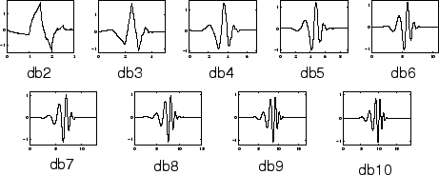

Figure 3.2. Daubechies wavelet [21].

Different types of daubechies wavelet is seen in Fig 4.2. Each of the wavelet is characterized differently from one to another. Frequency is being changed with each one of them differently. Higher values daubechies wavelet poses high frequency value where lower daubechies family reflects lower frequency.

Symlets:

The symlets are nearly symmetrical wavelets proposed by Daubechies as modifications to the  db family. The properties of the two wavelet families are similar. Here are the wavelet functions psi.

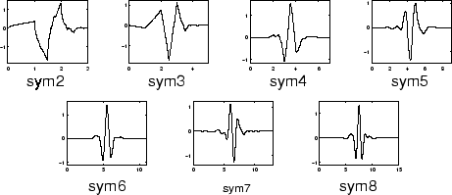

Figure 3.3. Symlets wavelet [22].

Fig 4.3 shows another wavelet important wavelet family which is symlet wavelet. We can do further modification of our frequency signal using these symlet. We can see the clear changes of the symlet family as it’s type number increases in fig 4.3.

### Wavelet Thresholding

Wavelet Thresholding, which works on one wavelet coefficient at a time, is a very simple non-linear technique. In its most simple form, and coefficient is set to zero by comparing the threshold with the threshold if the coefficient is lower than the threshold; otherwise, it is retained or changed.

The fundamental concept behind wavelet de-noising, or wavelet thresholding, is that for many real-world signals and images, wavelet transformation leads to a sparse representation. What this implies is that signal and image characteristics are concentrated in a few broad wavelet coefficients by the wavelet transform.

Another approach is soft thresholding by first setting zero coefficients whose absolute values are smaller than the threshold λ and then shrinking non-zero coefficients to zero. Data values with an absolute value less than param are replaced with a substitute in soft thresholding. Data values with an absolute value greater than or equal to the threshold value are reduced by a value to zero.

Hard thresholding is the mechanism by which coefficients whose absolute values are lower than the λ threshold are set to zero. Data values where their absolute value is less than the value parameter are substituted by substitute values in hard thresholding. Data values with absolute value greater or equal to the thresholding value stay untouched. Garrote corresponds to the Non-negative garrote threshold.

Garrote refers to the threshold of non-negative garrote. It is intermediate between hard and soft thresholds. It serves as a soft threshold for small data values and reaches hard thresholds for large data values.

In the case of higher thresholds, the data is substituted by a replacement where the data is below the threshold value. Greater data values will pass unchanged.

In the case of a lower threshold, the data is substituted by a replacement where the data exceeds the threshold value. Less data is transferred untouched.

### Wavelet Filters

The four output filters are

* Lo_D, the decomposition low-pass filter
* Hi_D, the decomposition high-pass filter
* Lo_R, the reconstruction low-pass filter
* Hi_R, the reconstruction high-pass filter

Wavelet decomposition filters, specified as pairs of real-value even-length vectors. LoD is a low-pass decomposition filter, and HiD is a high-pass decomposition filter. The lengths of LoD and HiD must be the same.

Wavelet reconstruction filters, defined as pairs of real-valued even-length vectors. LoR is a low-pass reconstruction filter, and HiR is a high-pass reconstruction filter. The lengths of LoR and HiR must be the same.

Low Pass filter: Low Pass filters for the DWT filter bank, returned as an L-by-2 matrix. L is a positive integer. The first column of Lo is a filter for analysis, and the second column is a filter for synthesis.

For orthogonal wavelets, the lowpass synthesis and lowpass analysis filters are time-reversed versions of each other.

High pass filter: Highpass (wavelet) filters for the DWT filter bank, returned as an L-by-2 matrix. L is an even positive integer. The first column of Hi is the analysis filter, and the second column is the synthesis filter.

For orthogonal wavelets, the highpass synthesis and highpass analysis filters are time-reversed versions of each other.

### Filter Banks

Filters for orthogonal and bi-orthogonal wavelets and scaling, lifting:

Orthogonal and bi-orthogonal filter banks are low-pass, high-pass, and band-pass filters that divide the data into sub-bands. If the sub-bands are not modified, these filters allow for a perfect reconstruction of the original data. In most applications, process data differently in different sub-bands and then reconstruct the modified version of the original data.

Orthogonal filter banks do not have a linear phase of operation. Bi-orthogonal filter banks have a linear phase. The number of disappearing moments can be specified by wavelet and scaling filters, allowing you to remove or retain polynomial behavior in your data. Lifting enables you to design perfect filter banks for reconstruction with specific properties.

### Wavelet Coefficient

The approximation, or scaling, of the coefficients is the low pass representation of the signal, and the details are the wavelet coefficients. At each subsequent level, the approximation coefficients are divided into the coarser approximation (low pass) and the high pass (detail) parts.

### Wavelet Energy

Relative wavelet energy (RWE) provides information on the relative energy associated with different frequency bands and can be regarded as the density of the time scale. RWE can be used in time and frequency planes as a tool for detecting and characterizing a specific phenomenon.

Energy = $\frac{\sum_{i=1}^{n}{{(x)}^{2}}}{n}$

**Chapter 4**

# Result & Discussion

Signal:



Figure 4.1. Amplitude distribution of heart sound recorded from healthy subjects.



Figure 4.2. Amplitude distribution of heart sound recorded from unhealthy subjects.

Fig 4.1 is an electrical signal converted from sound recorded from a healthy person. Heart sound is interpreted to electrical signal like that in time domain. These representation of sound can extract various features of sound. We can clearly see the heart’s lub dub in this fig 4.1. Fig 4.2 represents the electrical signal recorded from an unhealthy person in time domain. We can clearly see the differences between fig 4.1 to fig 4.2.

Comparison between healthy and unhealthy heart sound signal:



Figure 4.3. Comparison between healthy and unhealthy heart sound signal.

We can found clear idea and watch the differences between healthy and unhealthy subjects through comparison between them. Fig 4.3 shows us such comparison and we can see the variation in amplitude and frequency of these signals. Healthy person shows much higher amplitude than unhealthy person’s signal.

Spectrogram:

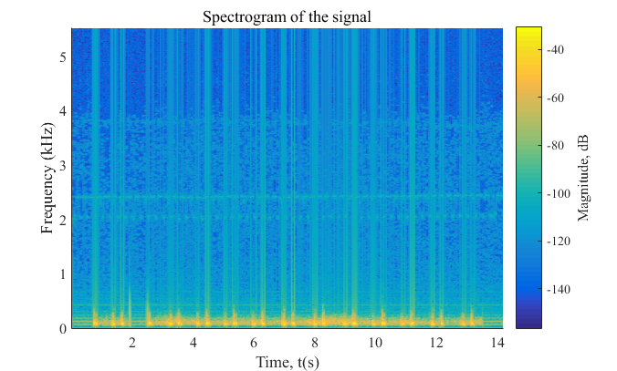

Figure 4.4. Spectrogram of heart sound recorded from healthy subjects**.**

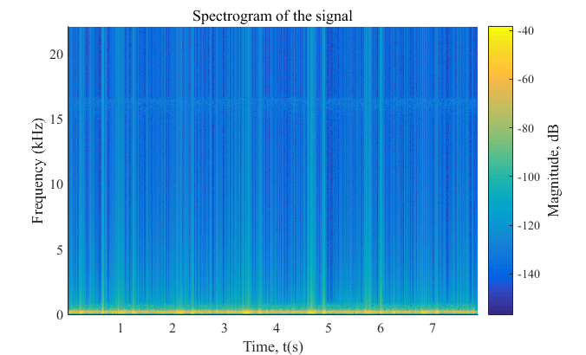

Figure 4.5. Spectrogram of heart sounds recorded from unhealthy subject.

Quadratic time-frequency analysis methods produce spectrograms, which are 2D matrices. Fig 4.4 and fig 4.5 shows us such spectral signal from healthy and unhealthy subjects. Fig 5.4 shows the intensity of the frequency content of the signal as time progresses. We can see fig 5.4 shows higher magnitude with constant variation in magnitude as time progresses. Fig 4.5 is more consistent with magnitude and small in value. We have seen lower magnitude value all around the spectrogram. Clear indication of differences in fig 4.4 and fig 4.5 is noticeable.

Histogram:



Figure 4.6. Plot of probability distribution of heart sound recorded from healthy subject.



Figure 4.7. Plot of probability distribution of heart sound recorded from unhealthy subject.

A histogram is used to summarize discrete or continuous data. Fig 4.6 shows Plot of probability distribution of heart sound recorded from healthy subject. It is more centric and for higher samples signal amplitude is high. Fig 4.7 showed us the plot of probability distribution of heart sound recorded from unhealthy subject. It poses lower amplitude value.

Normal Distribution: 

Figure 4.8. Plot of probability distribution of heart sound recorded from healthy subject.



Figure 4.9. Plot of probability distribution of heart sound recorded from unhealthy subject.

Probability distribution of heart sound recorded from healthy and unhealthy subject with normal distribution predicts the probability of a subject to be healthy or unhealthy. Probability made between 0 to 1with a belly shape normal distribution.

Mean Value Comparison: 

Figure 4.10. Mean value of healthy and unhealthy subject.

Fig 4.10 shows mean value comparison between healthy and unhealthy subjects. Recorded sound signal from healthy and unhealthy person shows wide variant of mean value. Although we have successfully found a threshold value range as isolation line between healthy and unhealthy subjects. Mean value isn’t same for all healthy value. Mean values variation is found due to different gender, age, body structure etc. So, when we can collect the heart sound data through data acquisition technique described above then by finding out the mean value of recorded sound signal we can tell whether the person is healthy or unhealthy.

Threshold level is found about (0.07-0.09) to differentiate between them.

Detailed Coefficient (cD): Wavelet family Sym4 is used here

Detailed coefficient for healthy and unhealthy subject:



Figure 4.11. De-noised detailed coefficient using sym4 level4 of healthy subject**.**



Figure 4.12. De-noised detailed coefficient using sym4 level4 of unhealthy subject**.**

**Here in these fig 4.11 and fig 4.12 we extracted detailed coefficient of one healthy and unhealthy person’s heart sound signal respectively. De-noising of collected heart signal is done so that further analysis of heart sound be accurate and efficient. Symlet wavelet family are being used here for better response. We used different symlet level starting from level 1 to level 4 and found a good response for symlet level 4. Clear differences between these two signals are shown in these figures. So we can count detailed coefficient of heart sound as a differentiating factor between healthy and unhealthy person.**

4 Levels of wavelet coefficient before de-noising:



Figure 4.13. Detailed Coefficient before de-noising the signal of healthy subject.



Figure 4.14. Detailed Coefficient before de-noising the signal of unhealthy subject**.**

Four different levels of symlet wavelet family using detailed coefficient for discrete wavelet transform are shown in fig 4.13 and fig 4.14. As level progresses from 1 to 4 accuracy of signal increases and unwanted noise being removed in an efficient way. We can also see the differences between levels before and after de-noising take place. Noise free signal wavelet levels are much more accurate than noisy signal symlet levels. Healthy and unhealthy signals show different characteristics even before being de-noised.

4 Level of wavelet coefficient after de-noising:



Figure 4.15. Detailed coefficient after de-noising the signal of healthy subject.



Figure 4.16. Detailed coefficient after de-noising the signal of unhealthy subject**.**

Four different levels of symlet wavelet family using detailed coefficient for discrete wavelet transform are shown in fig 4.15 and fig 4.16. As level progresses from 1 to 4 accuracy of signal increases and unwanted noise being removed in an efficient way. We can also see the differences between levels before and after de-noising take place. Noise free signal wavelet levels are much more accurate than noisy signal symlet levels. Healthy and unhealthy signals show different characteristics even after being de-noised.

Approximation Coefficient (cA): Wavelet family Sym4 is used here

Approximation coefficient of healthy and unhealthy subject:



Figure 4.17. De-noised approximation coefficient using sym4 level4 of healthy subject**.**



Figure 4.18. De-noised approximation coefficient using sym4 level4 of unhealthy subject**.**

**Here in these fig 4.17 and fig 4.18 we extracted approximation coefficient of one healthy and unhealthy person’s heart sound signal respectively. De-noising of collected heart signal is done so that further analysis of heart sound be accurate and efficient. Symlet wavelet family are being used here for better response. We used different symlet level starting from level 1 to level 4 and found a good response for symlet level 4. Clear differences between these two signals are shown in these figures. So we can count approximation coefficient of heart sound also as a differentiating factor between healthy and unhealthy person.**

4 Level of wavelet coefficient before de-noising:



Figure 4.19. Approximation Coefficient before de-noising the signal of healthy subject**.**



Figure 4.20. Approximation Coefficient before de-noising the signal of unhealthy subject**.**

Four different levels of symlet wavelet family using detailed coefficient for discrete wavelet transform are shown in fig 4.19 and fig 4.20. As level progresses from 1 to 4 accuracy of signal increases and unwanted noise being removed in an efficient way. We can also see the differences between levels before and after de-noising take place. Noise free signal wavelet levels are much more accurate than noisy signal symlet levels. Healthy and unhealthy signals show different characteristics even before being de-noised.

4 Level of wavelet coefficient after de-noising:



Figure 4.21. Approximation Coefficient after de-noising the signal of healthy subject**.**



Figure 4.22. Approximation Coefficient after de-noising the signal of unhealthy subject**.**

Four different levels of symlet wavelet family using detailed coefficient for discrete wavelet transform are shown in fig 4.21 and fig 4.22. As level progresses from 1 to 4 accuracy of signal increases and unwanted noise being removed in an efficient way. We can also see the differences between levels before and after de-noising take place. Noise free signal wavelet levels are much more accurate than noisy signal symlet levels. Healthy and unhealthy signals show different characteristics even after being de-noised.

Energy of DWT co-efficient:



Figure 4.23. Energy of DWT co-efficient of healthy and unhealthy subjects.

Zoomed version of unhealthy subjects:



Figure 4.24. Zoomed version of energy of DWT co-efficient of unhealthy subjects

Energy of discrete wavelet transform coefficient is derived by the simple equation of energy ,

Energy = $\frac{\sum_{i=1}^{n}{{(x)}^{2}}}{n}$. We plot the energy for each of healthy and unhealthy samples in fig 4.23 & fig 4.24 and find out the threshold value of 2e-08 to 0.5e-05 for differentiating between them. We saw that unhealthy samples energy is too much lower than the energy of healthy samples. So, this energy is being counted as a differentiating factor between healthy and unhealthy samples of heart sound.

Table 4.1. Range of Threshold to Separate Healthy and Unhealthy Heart Sounds for Automated Diagnosis of Cardiac Disorders.

|  |  |  |  |  |
| --- | --- | --- | --- | --- |
| Features | Max. value of  unhealthy samples for  threshold selection | Min value of  Healthy samples for threshold  selection | Range for  threshold | Feature  considered for  separation of  healthy and unhealthy heart sounds |
| Absolute mean: Signal Amplitude | 0.07  Yes | 0.09 | 0.07 to  0.09 | Yes |
| Energy of DWT | 2e-08 | 0.5e-05 | 2e-08 to 0.5e-05 | Yes |

**Chapter 5**

# Conclusion and Future Work

## Conclusion

Body auscultation is a key and effective human health assessment clinical diagnostic procedure. For automated screening of cardiac disorders, this thesis book introduced heart sound analysis for differentiation of heart sounds collected from health and unhealthy subjects. Features derived from signal amplitude distribution in the time domain and frequency domain analysis reveals that mean frequency is discriminatory enough to distinguish healthy and unhealthy heart. The results of the experiment showed adequate discrimination between the characteristics of heart sounds for automatic screening of cardiac problems using signal processing from healthy/unhealthy heart sounds. Mean Threshold level is found about (0.06-0.09). Above the threshold value is healthy subject and below the threshold value is unhealthy subject. Another strategy for automatic screening of cardiac conditions from heart sounds is based on machine learning. To derive discriminatory features from wavelet heart sound coefficients, the heart sound signal was converted into the wavelet domain.

## Future Work

An IOT based system can be improved so that the data collected from far area can easily transferred to the server to do the analysis. Then update information about the health condition could be supplied to a person. If we found any abnormality we can check it earlier before it’s getting worse. Many transform technique can be used for further extraction of different features in the biomedical field. Artificial intelligence can also be used is this sector for better output and discriminatory features. Machine learning can also be used for accurate diagnosis of cardiac diseases from heart sound.

**References**

[1] Gjoreski, Martin, Anton Gradišek, Borut Budna, Matjaž Gams, and Gregor Poglajen. "Machine learning and end-to-end deep learning for the detection of chronic heart failure from heart sounds." *IEEE Access* 8 (2020): 20313-20324.

[2] Qiao, P. A. N., Z. H. A. N. G. Yu, Z. H. A. N. G. Jingyi, and C. H. E. N. Zhuo. "A method for diagnosing heart sounds in adolescents based on wavelet analysis and random forest." In *2020 International Conference on Big Data, Artificial Intelligence and Internet of Things Engineering (ICBAIE)*, pp. 69-74. IEEE, 2020.

[3] Tsai, Kun-Hsi, Wei-Chien Wang, Chui-Hsuan Cheng, Chan-Yen Tsai, Jou-Kou Wang, Tzu-Hao Lin, Shih-Hau Fang, Li-Chin Chen, and Yu Tsao. "Blind Monaural Source Separation on Heart and Lung Sounds Based on Periodic-Coded Deep Autoencoder." *IEEE Journal of Biomedical and Health Informatics* 24, no. 11 (2020): 3203-3214.

[4] Li, Haixia, Guofeng Ren, Xiaopu Yu, Dongying Wang, and Shizhe Wu. "Discrimination of the Diastolic Murmurs in Coronary Heart Disease and in Valvular Disease." *IEEE Access* 8 (2020): 160407-160413.

[5] Das, Sangita, Saurabh Pal, and Madhuchhanda Mitra. "Acoustic feature based unsupervised approach of heart sound event detection." *Computers in Biology and Medicine*126 (2020): 103990.

[6] Upretee, Pratima, and Mehmet Emin Yüksel. "Accurate Classification of Heart Sounds for Disease Diagnosis by A Single Time-Varying Spectral Feature: Preliminary Results." In *2019 Scientific Meeting on Electrical-Electronics & Biomedical Engineering and Computer Science (EBBT)*, pp. 1-4. IEEE, 2019.

[7] Xiao, Bin, Yunqiu Xu, Xiuli Bi, Weisheng Li, Zhuo Ma, Junhui Zhang, and Xu Ma. "Follow the Sound of Children’s Heart: A Deep-Learning-Based Computer-Aided Pediatric CHDs Diagnosis System." *IEEE Internet of Things Journal* 7, no. 3 (2019): 1994-2004.

[8] Li, Haixia, Yongfeng Ren, Guojun Zhang, Renxin Wang, Jiangong Cui, and Wendong Zhang. "Detection and classification of abnormities of first heart sound using empirical wavelet transform." *IEEE Access* 7 (2019): 139643-139652.

[9] Elamaran, V., N. Arunkumar, Ahmed Faeq Hussein, Mario Solarte, and Gustavo Ramirez-Gonzalez. "Spectral fault recovery analysis revisited with Normal and abnormal heart sound signals." *IEEE Access* 6 (2018): 62874-62879.

[10] Dwivedi, Amit Krishna, Syed Anas Imtiaz, and Esther Rodriguez-Villegas. "Algorithms for automatic analysis and classification of heart sounds–a systematic review." *IEEE Access* 7 (2018): 8316-8345.

[11] Demir, Fatih, Abdulkadir Şengür, and Mehmet Çavaş. "HEART SOUNDS CLASSIFICATION WITH DEEP FEATURES AND SUPPORT VECTOR MACHINES." In *2018 International Conference on Artificial Intelligence and Data Processing (IDAP)*, pp. 1-5. IEEE, 2018.

#### [12] Mondal, Ashok, Ishan Saxena, Hong Tang, and Poulami Banerjee. "A noise reduction technique based on nonlinear kernel function for heart sound analysis." *IEEE journal of biomedical and health informatics* 22, no. 3 (2017): 775-784.

[13] Glazova, Anna, Zafar Yuldashev, and Anna Bashkova. "A method and algorithm for remote monitoring of patients in asthma." In *2018 Ural Symposium on Biomedical Engineering, Radioelectronics and Information Technology (USBEREIT)*, pp. 83-86. IEEE, 2018.

[14] Li, Zhi, Harm Derksen, Jonathan Gryak, Mohsen Hooshmand, Alexander Wood, Hamid Ghanbari, Pujitha Gunaratne, and Kayvan Najarian. "Supraventricular Tachycardia Detection via achine Learning Algorithms." In *2018 IEEE International Conference on Bioinformatics and Biomedicine (BIBM)*, pp. 2419-2422. IEEE, 2018.

[15] Mishra, Mohan, Anushikha Singh, Malay Kishore Dutta, and Alfredo Rosado Muñoz. "Automatic screening of cardiac disorders using wavelet analysis of heart sound." In *2017 4th IEEE Uttar Pradesh Section International Conference on Electrical, Computer and Electronics (UPCON)*, pp. 472-476. IEEE, 2017.

[16] Mohammad-Taheri, Sina, Mohammad-Ali Masnadi Shirazi, and Amin Rafiezade. "Slope analysis based methods for detection of ventricular fibrillation and ventricular tachycardia." In *2016 24th Iranian Conference on Electrical Engineering (ICEE)*, pp. 1100-1103. IEEE, 2016.

[17] http://www.scielo.org.co/scielo.php?script=sci_arttext&pid=S0120-62302012000300016

[18] <https://physionet.org/content/ecgiddb/1.0.0>

[19] https://en.wikipedia.org/wiki/Arduino_Uno

[20] https://www.mayoclinic.org/diseases-conditions/heart-arrhythmia/symptoms-causes/syc-20350668

[21] http://matlab.izmiran.ru/help/toolbox/wavelet/ch01_31a.html

[22] <http://matlab.izmiran.ru/help/toolbox/wavelet/ch01_34a> html